**Wireframe**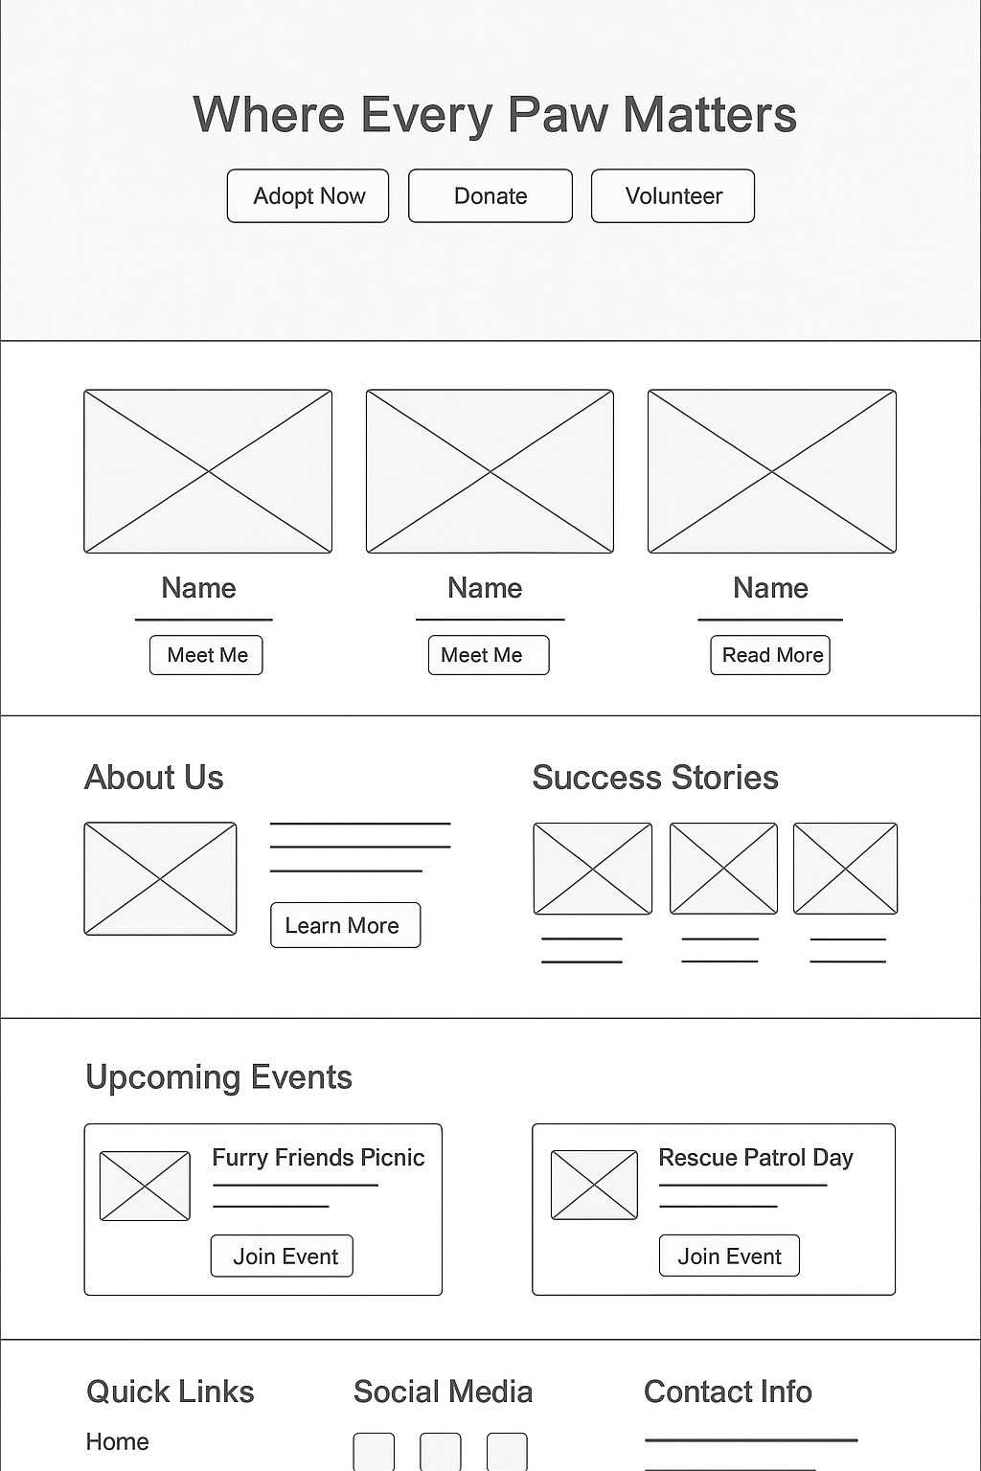

**Mockup**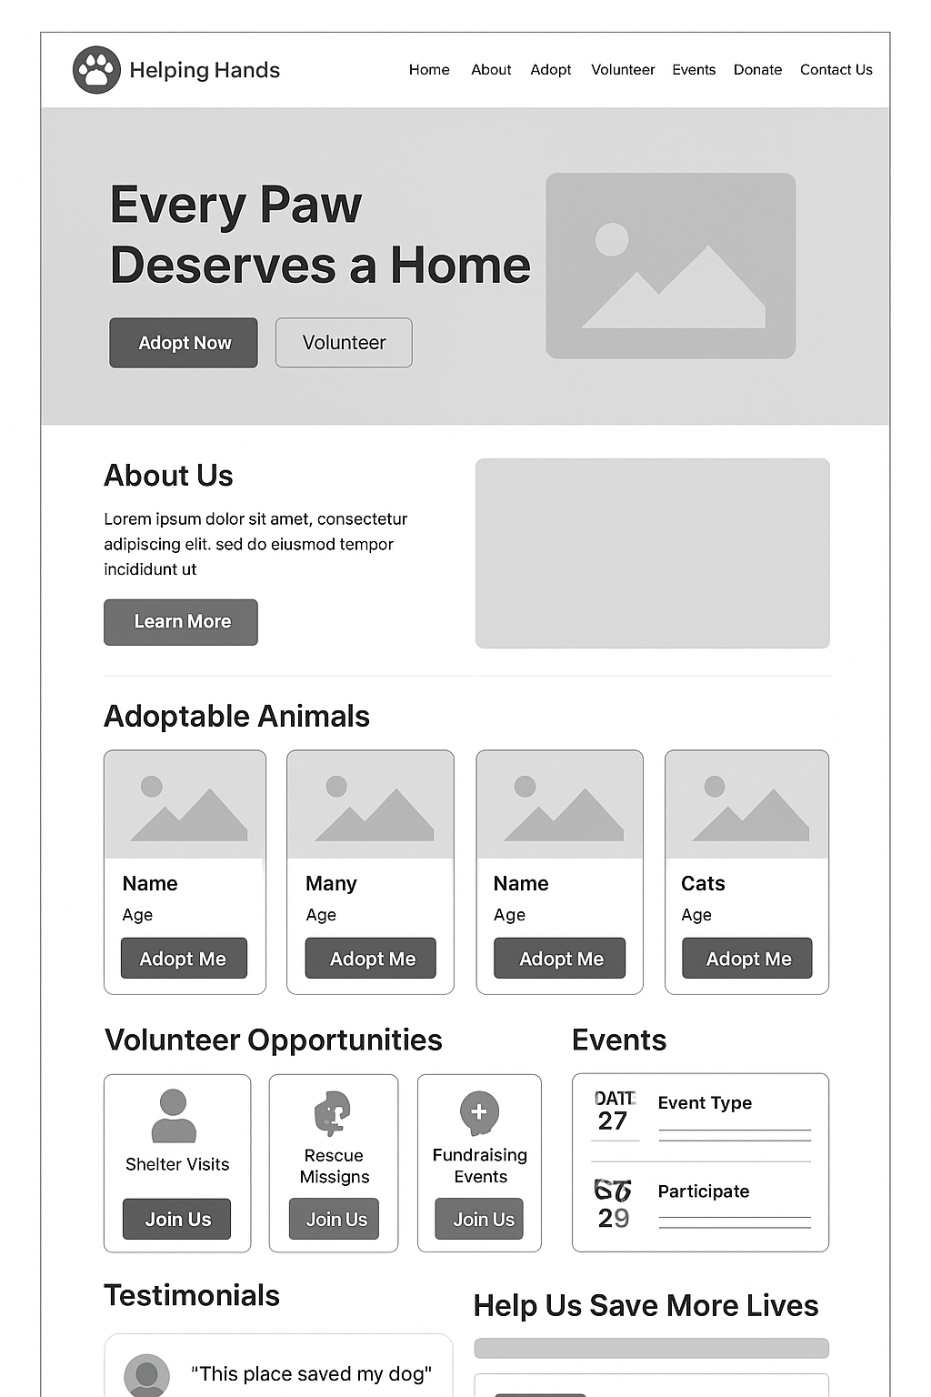

1. Home Page

Header:

* Logo (top-left)
* Navigation: Home | About Us | Adoption | Events | Donate | Contact Us

Hero Section:

* Big banner image of rescued animals
* Text overlay: “Helping Hands Animal Rescue – Caring for Our Furry Friends”
* Call-to-Action (CTA) button: “Adopt Now”

Features Section:

* 3-4 cards showing:
  + “Adopt an Animal”
  + “Volunteer Opportunities”
  + “Donate”
  + “Upcoming Events”

Footer:

* Contact info, social media links, newsletter signup

2. About Us Page

* Mission statement
* Team photos
* Testimonials from adopters

3. Adoption Page

* Search/filter animals by type (dog, cat, etc.)
* Each animal has:
  + Picture
  + Name & Age
  + Short description
  + “Adopt Me” button

4. Events Page

* Upcoming events list with date, time, location
* Examples:
  + “Picnic with Pets”
  + “Volunteer Rescue Day”

5. Contact Page

* Simple contact form (Name, Email, Message)
* Map of shelter location